Experiment 1: Data Exploration and Cleaning with pandas

Program:
import pandas as pd
import matplotlib.pyplot as plt
# Step 1: Load the dataset
df = pd.read_csv("student_marks.csv")
# Step 2: Explore the dataset
print("First five rows:")
print(df.head())
print("\nDataset Shape:")
print(df.shape)
print("\nDataset Information:")
df.info()
print("\nStatistical Description:")
print(df.describe())
# Step 3: Find missing values
print("\nMissing Values:")
print(df.isna().sum())
# Step 4: Remove duplicate rows
df = df.drop_duplicates()
# Step 5: Handle missing numerical values
num_cols = ["attendance", "internal", "final_exam", "study_hours"]
for col in num_cols:
df[col] = df[col].fillna(df[col].median())
# Step 6: Handle missing categorical values
cat_cols = ["department", "gender"]
for col in cat_cols:
df[col] = df[col].fillna(df[col].mode()[0])
# Step 7: Remove impossible attendance values
df = df[(df["attendance"] >= 0) & (df["attendance"] <= 100)]

# Step 8: Calculate final exam statistics
print("\nFinal Exam Statistics:")
print("Mean:", df["final_exam"].mean())
print("Median:", df["final_exam"].median())
print("Standard Deviation:", df["final_exam"].std())
print("Minimum:", df["final_exam"].min())
print("Maximum:", df["final_exam"].max())
# Step 9: Compare department-wise marks
print("\nDepartment-wise Average:")
print(df.groupby("department")["final_exam"].mean())
# Step 10: Draw Histogram
plt.figure(figsize=(6, 4))
plt.hist(df["final_exam"], bins=5, edgecolor="black")
plt.title("Final Exam Marks Distribution")
plt.xlabel("Final Exam Marks")
plt.ylabel("Number of Students")
plt.show()
# Step 11: Draw Box Plot
plt.figure(figsize=(6, 4))
df.boxplot(column="final_exam", by="department")
plt.title("Final Exam Marks by Department")
plt.suptitle("")
plt.xlabel("Department")
plt.ylabel("Final Exam Marks")
plt.show()
# Step 12: Draw Scatter Plot
plt.figure(figsize=(6, 4))
plt.scatter(df["study_hours"], df["final_exam"])
plt.title("Study Hours vs Final Exam Marks")
plt.xlabel("Study Hours")
plt.ylabel("Final Exam Marks")
plt.show()
# Step 13: Calculate correlation
correlation = df["study_hours"].corr(df["final_exam"])
print("\nCorrelation:", correlation)
# Step 14: Save cleaned dataset
df.to_csv("student_marks_clean.csv", index=False)
print("\nCleaned dataset saved successfully!")
Output:
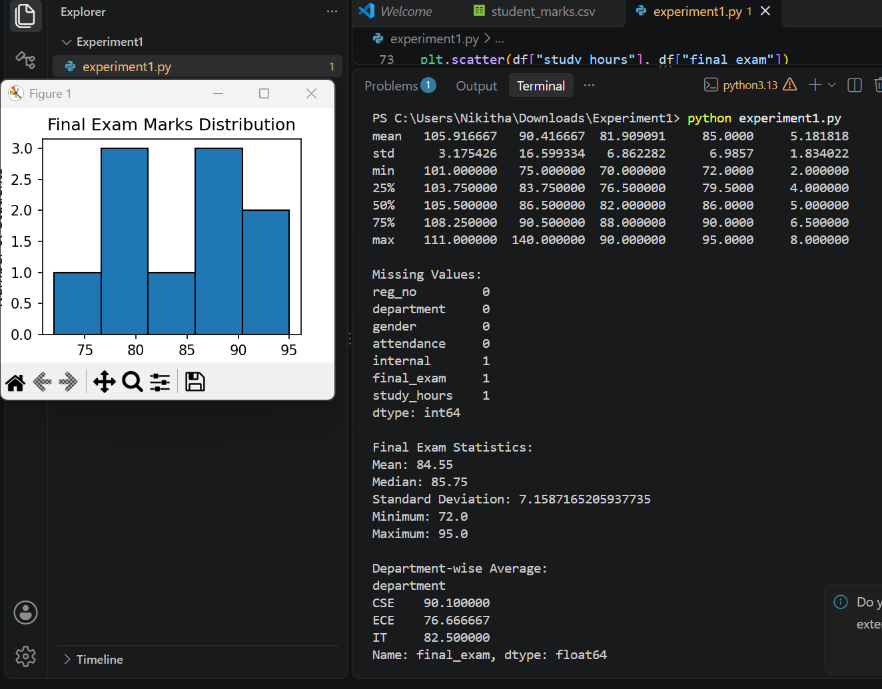

Experiment 2: Semantic Network and Inheritance Queries

Program:
import networkx as nx
import matplotlib.pyplot as plt
from collections import deque
# Step 1: Create a directed graph
G = nx.DiGraph()
# Step 2: Add nodes
nodes = [
"Animal", "Bird", "Fish",
"Canary", "Penguin", "Tweety",
"fly", "wings", "yellow"
]
G.add_nodes_from(nodes)
# Step 3: Add inheritance relationships
G.add_edge("Bird", "Animal", relation="is-a")
G.add_edge("Fish", "Animal", relation="is-a")
G.add_edge("Canary", "Bird", relation="is-a")
G.add_edge("Penguin", "Bird", relation="is-a")
G.add_edge("Tweety", "Canary", relation="instance-of")
# Step 4: Add properties
G.add_edge("Bird", "fly", relation="can")
G.add_edge("Bird", "wings", relation="has-part")
G.add_edge("Penguin", "fly", relation="cannot")
G.add_edge("Canary", "yellow", relation="colour")
# Step 5: Create inheritance function
def inherits(node, relation):
queue = deque([node])
visited = set()
while queue:
current = queue.popleft()
if current in visited:
continue
visited.add(current)
# Check properties of current node
for neighbor in G.successors(current):
edge_relation = G[current][neighbor]["relation"]
if relation == "can":
if edge_relation in ["can", "cannot"]:
return edge_relation + " " + neighbor
elif edge_relation == relation:
return neighbor
# Move to parent node
for neighbor in G.successors(current):
edge_relation = G[current][neighbor]["relation"]
if edge_relation in ["is-a", "instance-of"]:
queue.append(neighbor)

return "Property not found"
# Step 6: Test inheritance queries
print("SEMANTIC NETWORK QUERIES")
print("1. Can Tweety fly?",
inherits("Tweety", "can"))
print("2. Does Tweety have wings?",
inherits("Tweety", "has-part"))
print("3. What is the colour of Canary?",
inherits("Canary", "colour"))
print("4. Can Penguin fly?",
inherits("Penguin", "can"))
print("5. Does Bird have wings?",
inherits("Bird", "has-part"))
# Step 7: Find shortest path
path = nx.shortest_path(G, "Tweety", "Animal")
print("\nPath from Tweety to Animal:")
print(" -> ".join(path))
# Step 8: Draw semantic network
pos = nx.spring_layout(G, seed=42)
nx.draw(
G,
pos,
with_labels=True,
node_color="lightblue",
node_size=2500,
font_size=9,
arrows=True
)
edge_labels = nx.get_edge_attributes(G, "relation")

nx.draw_networkx_edge_labels(
G,
pos,
edge_labels=edge_labels,
font_size=8
)
plt.title("Semantic Network of Animals")
plt.show()
Output:
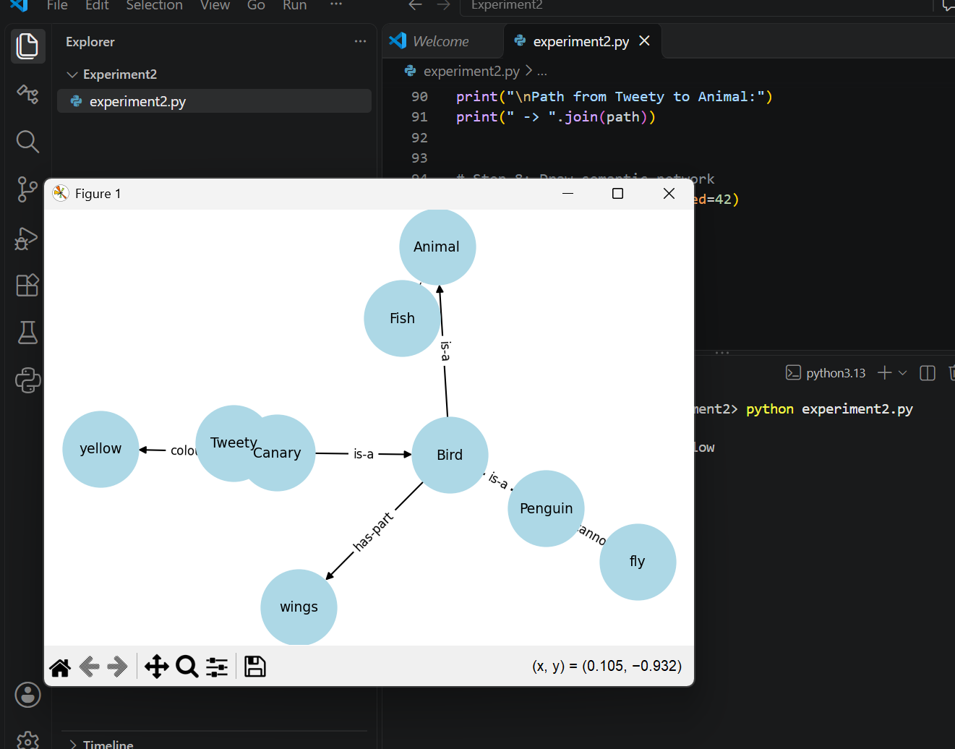

Experiment 3: Frames with Defaults, Inheritance and If-Needed Procedures

Program:
# Experiment 3: Frames with Defaults and Inheritance
# Special value to identify an empty slot
MISSING = object()
# Step 1: Create Frame class
class Frame:
def __init__(self, name, parent=None):
self.name = name
self.parent = parent
self.slots = {}
# Step 2: Add slots
def add_slot(self, slot, value=MISSING,
default=MISSING, if_needed=None,
if_added=None):
self.slots[slot] = {
"value": value,
"default": default,
"if_needed": if_needed,
"if_added": if_added
}
# Step 3: Get slot value
def get(self, slot):
if slot in self.slots:
data = self.slots[slot]
if data["value"] is not MISSING:
return data["value"], "Frame value"
if data["if_needed"] is not None:
return data["if_needed"](self), "If-needed procedure"

if data["default"] is not MISSING:
return data["default"], "Default value"
# Search in parent frame
if self.parent is not None:
return self.parent.get(slot)
return None, "Not found"
# Step 4: Set slot value
def set(self, slot, value):
if slot not in self.slots:
self.add_slot(slot)
self.slots[slot]["value"] = value
procedure = self.slots[slot]["if_added"]
if procedure is not None:
procedure(value)
# Step 5: Define if-needed procedure
def calculate_mileage(frame):
odometer, _ = frame.get("odometer")
fuel_used, _ = frame.get("fuel_used")
if fuel_used == 0:
return "Cannot calculate mileage"
return odometer / fuel_used
# Step 6: Define if-added procedure
def check_mileage(value):
if value < 0:
print("Warning: Mileage cannot be negative!")
# Step 7: Create Vehicle frame
Vehicle = Frame("Vehicle")
Vehicle.add_slot("wheels", default=4)
Vehicle.add_slot("fuel_type", default="Petrol")

# Step 8: Create Car frame
Car = Frame("Car", Vehicle)
Car.add_slot("seats", default=5)
# Step 9: Create MyCar frame
MyCar = Frame("MyCar", Car)
MyCar.add_slot("odometer", value=12000)
MyCar.add_slot("fuel_used", value=600)
MyCar.add_slot(
"mileage",
if_needed=calculate_mileage,
if_added=check_mileage
)
# Step 10: Display slot values
print("FRAME VALUES OF MY CAR")
slots = [
"wheels",
"fuel_type",
"seats",
"odometer",
"fuel_used",
"mileage"
]
for slot in slots:
value, source = MyCar.get(slot)
print(slot, ":", value, "| Source:", source)
# Step 11: Demonstrate if-added procedure
print("\nDEMONSTRATING IF-ADDED PROCEDURE")
MyCar.set("mileage", -5)
print("Updated mileage:", MyCar.get("mileage")[0])

Output:
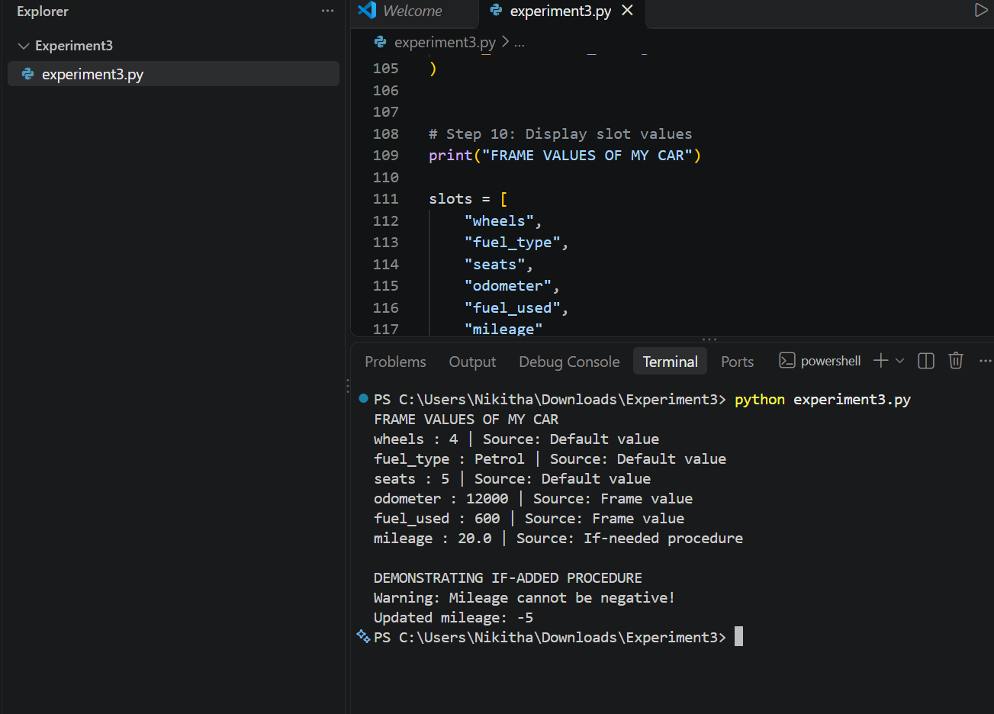
Experiment 4: Rule-Based System with Forward Chaining
Program:
# Experiment 4: Rule-Based System with Forward Chainin
# Step 1: Define rules
rules = [
("R1", {"income_ok", "credit_good"}, "financially_sound"),
("R2", {"employment_stable", "debt_low"}, "repayment_capacity"),
("R3", {"age_ok", "documents_verified"}, "profile_verified"),
("R4", {"financially_sound", "repayment_capacity"}, "loan_recommended"),
("R5", {"profile_verified", "loan_recommended"}, "approve"),
("R6", {"credit_poor"}, "credit_risk"),
("R7", {"credit_risk", "repayment_capacity"}, "manual_review"),
("R8", {"income_low"}, "income_risk"),
("R9", {"income_risk", "credit_good"}, "reject"),
("R10", {"income_ok", "credit_good", "employment_stable"},
"strong_profile")
]

# Step 2: Forward chaining function
def forward_chaining(initial_facts, strategy="first"):
facts = set(initial_facts)
cycle = 1
print("\nInitial Facts:", facts)
while True:
# Find all matching rules
conflict_set = []
for rule_id, conditions, conclusion in rules:
if conditions.issubset(facts) and conclusion not in facts:
conflict_set.append(
(rule_id, conditions, conclusion)
)
# Stop if no rule matches
if not conflict_set:
print("\nNo more rules can be fired.")
break
print("\nCycle:", cycle)
print("Conflict Set:",
[rule[0] for rule in conflict_set])
# Step 3: Select a rule
if strategy == "first":
selected_rule = conflict_set[0]
elif strategy == "specific":
selected_rule = max(
conflict_set,
key=lambda rule: len(rule[1])
)
# Step 4: Fire the selected rule
rule_id, conditions, conclusion = selected_rule

print("Fired Rule:", rule_id)
print("New Conclusion:", conclusion)
# Step 5: Add conclusion to working memory
facts.add(conclusion)
print("Updated Facts:", facts)
cycle += 1
return facts
# Step 6: Test Case 1 - Good loan applicant
test1 = {
"income_ok",
"credit_good",
"employment_stable",
"debt_low",
"age_ok",
"documents_verified"
}
print("\n========== TEST CASE 1 ==========")
result1 = forward_chaining(test1, "first")
print("\nFinal Conclusions:", result1)
# Step 7: Test Case 2 - Credit risk applicant
test2 = {
"credit_poor",
"employment_stable",
"debt_low",
"age_ok",
"documents_verified"
}
print("\n========== TEST CASE 2 ==========")
result2 = forward_chaining(test2, "first")

print("\nFinal Conclusions:", result2)
# Step 8: Test Case 3 - No matching rules
test3 = {
"student",
"has_id"
}
print("\n========== TEST CASE 3 ==========")
result3 = forward_chaining(test3, "first")
print("\nFinal Conclusions:", result3)
# Step 9: Compare conflict resolution strategies
print("\n========== STRATEGY COMPARISON ==========")
print("\nFirst Match Strategy:")
first_result = forward_chaining(test1, "first")
print("\nMost Specific Strategy:")
specific_result = forward_chaining(test1, "specific")
Output:
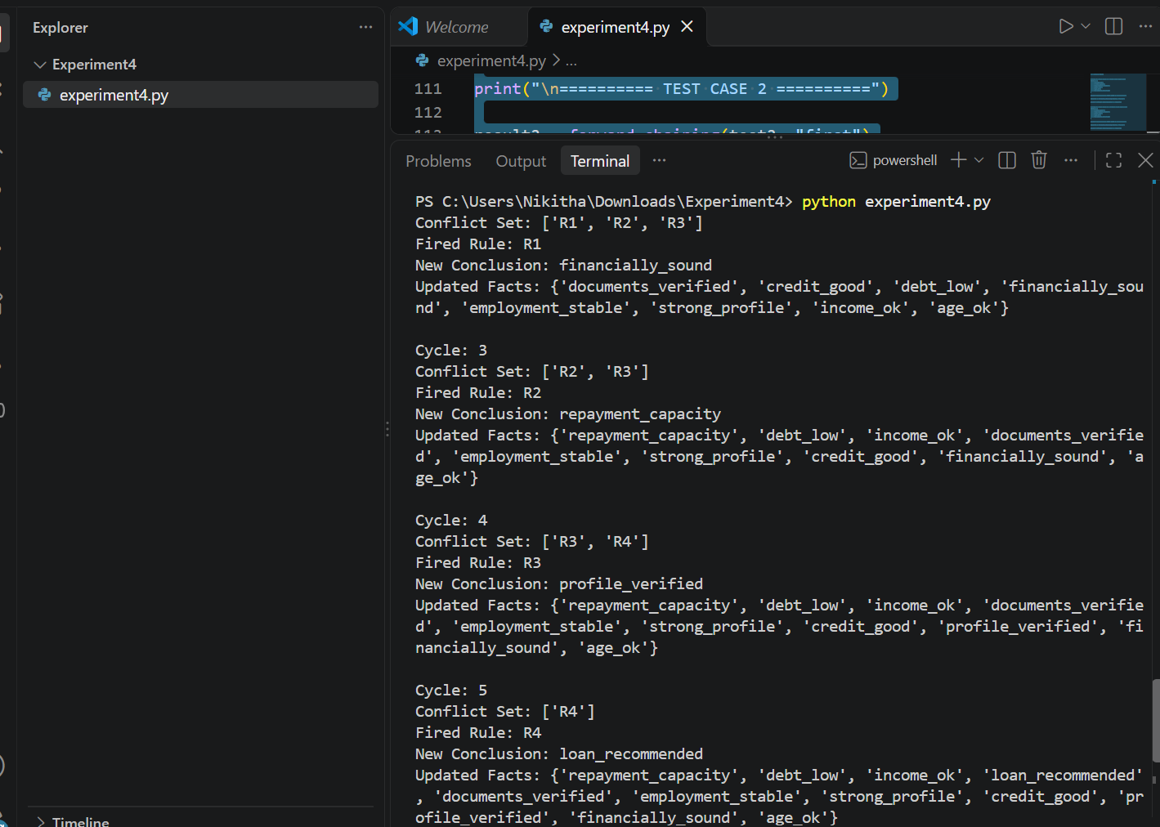

Experiment 5: Backward Chaining with a Why/How Explanation Facility
Program:
# EXPERIMENT 5
# Backward Chaining with Why/How Explanation Facility
# Step 1: Define rules
rules = [
(["yellow_leaves", "white_spots", "high_humidity"], "fungal_disease"),
(["brown_spots", "wilting", "high_humidity"], "fungal_disease"),
(["water_soaked_spots", "yellow_leaves"], "bacterial_disease"),
(["stem_canker", "wilting"], "bacterial_disease"),
(["holes_in_leaves", "visible_insects"], "pest_infestation"),
(["curled_leaves", "sticky_residue"], "pest_infestation"),
(["green_leaves", "no_spots", "no_insects"], "healthy_plant"),
(["normal_growth", "no_wilting"], "healthy_plant"),
(["fungal_disease", "severe_wilting"], "urgent_attention"),
(["bacterial_disease", "severe_wilting"], "urgent_attention"),
(["pest_infestation", "severe_damage"], "urgent_attention"),
(["healthy_plant", "normal_growth"], "healthy_status")
]
# Step 2: Define observable facts
askable = {
"yellow_leaves", "white_spots", "high_humidity",
"brown_spots", "wilting", "water_soaked_spots",
"stem_canker", "holes_in_leaves", "visible_insects",
"curled_leaves", "sticky_residue", "green_leaves",
"no_spots", "no_insects", "normal_growth",
"no_wilting", "severe_wilting", "severe_damage"
}
# Step 3: Initialize variables
facts = {}
proof_trace = []
asked_questions = []
rule_checks = 0
# Step 4: Backward chaining function
def prove(goal, required_by="the consultation"):
global rule_checks
# Check whether the fact is already known
if goal in facts:
return facts[goal]
# Ask the user for observable facts
if goal in askable:
answer = input(
f"Is {goal.replace('_', ' ')} present? (yes/no/why): "
).lower().strip()
if answer == "why":
print("WHY: This information is needed to prove", required_by)
answer = input("Please answer (yes/no): ").lower().strip()
while answer not in ["yes", "no"]:
answer = input("Please enter yes or no: ").lower().strip()
facts[goal] = (answer == "yes")
asked_questions.append(goal)
return facts[goal]
# Find rules that can prove the goal
for conditions, conclusion in rules:
if conclusion == goal:
rule_checks += 1
all_true = True
for condition in conditions:
if not prove(condition, goal):
all_true = False
break

if all_true:
facts[goal] = True
proof_trace.append(
f"{' AND '.join(conditions)} -> {conclusion}"
)
return True
facts[goal] = False
return False
# Step 5: Explain how the goal was proved
def explain_how(goal):
print("\nHOW EXPLANATION")
print("----------------")
if facts.get(goal, False):
print("The goal", goal, "was proved using these rules:")
for rule in proof_trace:
print(rule)
else:
print("The goal could not be proved.")
# Step 6: Forward chaining function for comparison
def forward_chaining(initial_facts):
known_facts = {
fact for fact, value in initial_facts.items() if value
}
forward_checks = 0
while True:
new_fact_found = False
for conditions, conclusion in rules:
forward_checks += 1
if all(condition in known_facts for condition in conditions):
if conclusion not in known_facts:

known_facts.add(conclusion)
new_fact_found = True
if not new_fact_found:
break
return known_facts, forward_checks
# Step 7: Main program
print("PLANT DISEASE DIAGNOSIS SYSTEM")
print("Available goals:")
print("1. fungal_disease")
print("2. bacterial_disease")
print("3. pest_infestation")
print("4. healthy_plant")
print("5. urgent_attention")
print("6. healthy_status")
goal = input("\nEnter your goal: ").lower().strip()
if goal not in [
"fungal_disease",
"bacterial_disease",
"pest_infestation",
"healthy_plant",
"urgent_attention",
"healthy_status"
]:
print("Invalid goal. Please enter a goal from the list.")
else:
result = prove(goal)
print("\nBACKWARD CHAINING RESULT")
print("-----------------------")
if result:
print("Goal", goal, "is PROVED.")
else:
print("Goal", goal, "could NOT be proved.")
explain_how(goal)
print("\nQUESTIONS ASKED:", len(asked_questions))
print("BACKWARD RULE CHECKS:", rule_checks)
# Compare with forward chaining
forward_facts, forward_checks = forward_chaining(facts)
print("\nFORWARD CHAINING COMPARISON")
print("--------------------------")
print("Facts derived:", forward_facts)
print("Forward rule checks:", forward_checks)
print("\nCOMPARISON")
print("Backward chaining asks questions to prove a specific goal.")
print("Forward chaining derives conclusions from available facts.")
Output:
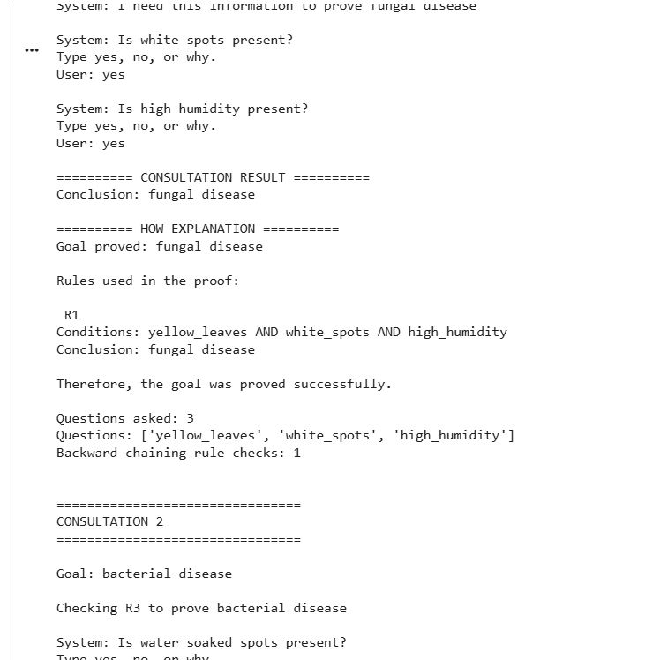

Experiment 6: Building and Reasoning over an Ontology
Program:
# EXPERIMENT 6
# Ontology Creation and Reasoning Using Owlready2

from owlready2 import *
# Step 1: Create an ontology
onto = get_ontology("http://example.org/student_ontology.owl")
with onto:
# Step 2: Create classes
class Person(Thing):
pass
class Student(Person):
pass
class Course(Thing):
pass
# Step 3: Create subclass
class GraduateStudent(Student):
pass
# Step 4: Create object property
class enrolled_in(ObjectProperty):
domain = [Student]
range = [Course]
# Step 5: Create data property
class completed_credits(DataProperty):
domain = [Student]
range = [int]
# Step 6: Define reasoning condition
GraduateStudent.equivalent_to.append(
Student & completed_credits.some(
ConstrainedDatatype(int, min_inclusive=120)
)
)
# Step 7: Create individuals
student1 = Student("student1")
student2 = Student("student2")
course1 = Course("Python")
course2 = Course("Java")
# Step 8: Assign data property values
student1.completed_credits = [130]
student2.completed_credits = [60]
# Step 9: Assign object property values
student1.enrolled_in = [course1]
student2.enrolled_in = [course2]
# Step 10: Display ontology details
print("ONTOLOGY DETAILS")
print("----------------")
print("\nClasses:")
for cls in onto.classes():
print(cls.name)
print("\nIndividuals:"
for individual in onto.individuals():
print(individual.name)
# Step 11: Perform reasoning
print("\nONTOLOGY REASONING")
print("------------------"
sync_reasoner([onto])
print("Reasoning completed successfully!")

# Step 12: Display inferred knowledge
print("\nINFERRED KNOWLEDGE")
print("------------------")
for student in [student1, student2]:
print("\nStudent:", student.name)
print("Completed Credits:", student.completed_credits)

print("Enrolled Courses:")
for course in student.enrolled_in:
print(course.name)
if GraduateStudent in student.is_a:
print("Inferred Class: GraduateStudent")
else:
print("Inferred Class: Student")
# Step 13: Display final result
print("\nFINAL RESULT")
print("------------")
print(
"Student1 is a GraduateStudent:",
GraduateStudent in student1.is_a
)
print(
"Student2 is a GraduateStudent:",
GraduateStudent in student2.is_a
)
# Step 14: Save ontology
onto.save(file="student_ontology.owl", format="rdfxml")
print("\nOntology saved successfully!")

Output:
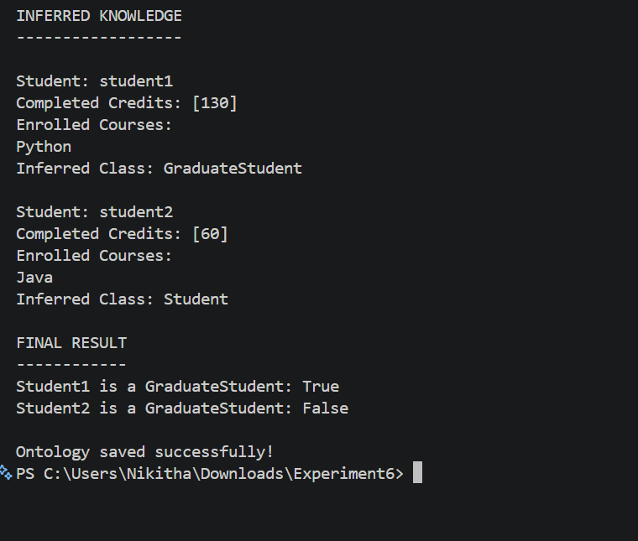

Experiment 7: Building and Querying a Knowledge Graph
Program:
# Building and Querying a Knowledge Graph Using RDFLi
from rdflib import Graph, Namespace, Literal, RDF, RDFS
# Step 1: Create an empty knowledge graph
g = Graph()
# Step 2: Create a namespace
EX = Namespace("http://example.org/")
# Step 3: Bind the namespace
g.bind("ex", EX)
# Step 4: Create student individuals
nikitha = EX.Nikitha
rahul = EX.Rahul
# Step 5: Create course individuals
ai = EX.AI
data_science = EX.DataScience
# Step 6: Create skill individuals
python_skill = EX.Python
java_skill = EX.Java
ml_skill = EX.MachineLearning
# Step 7: Add student information
g.add((nikitha, RDF.type, EX.Student))
g.add((nikitha, EX.name, Literal("Nikitha")))
g.add((nikitha, EX.enrolledIn, ai))
g.add((nikitha, EX.hasSkill, python_skill))
g.add((nikitha, EX.hasSkill, ml_skill))
g.add((rahul, RDF.type, EX.Student))
g.add((rahul, EX.name, Literal("Rahul")))
g.add((rahul, EX.enrolledIn, data_science))
g.add((rahul, EX.hasSkill, java_skill))
# Step 8: Add course information
g.add((ai, RDF.type, EX.Course))
g.add((ai, RDFS.label, Literal("Artificial Intelligence")))
g.add((data_science, RDF.type, EX.Course))
g.add((data_science, RDFS.label, Literal("Data Science")))
# Step 9: Add skill information
g.add((python_skill, RDF.type, EX.Skill))
g.add((java_skill, RDF.type, EX.Skill))
g.add((ml_skill, RDF.type, EX.Skill))
# Step 10: Display all triples
print("KNOWLEDGE GRAPH")
print("----------------")
for subject, predicate, obj in sorted(g, key=lambda triple: tuple(map(str, triple))):
print(
subject.split("/")[-1],
predicate.split("/")[-1],
obj if isinstance(obj, Literal) else obj.split("/")[-1]
)
# Step 11: Query students enrolled in AI
print("\nSTUDENTS ENROLLED IN AI")
print("-----------------------")
query1 = """
PREFIX ex: <http://example.org/>
SELECT ?student
WHERE {
?student ex:enrolledIn ex:AI .
}
"""
results = g.query(query1)
for row in results:
print(row.student.split("/")[-1])
# Step 12: Query students having Python skill
print("\nSTUDENTS HAVING PYTHON SKILL")
print("----------------------------")
query2 = """
PREFIX ex: <http://example.org/>
SELECT ?student
WHERE {
?student ex:hasSkill ex:Python .
}
"""
results = g.query(query2)
for row in results:
print(row.student.split("/")[-1])
# Step 13: Query student names and their courses
print("\nSTUDENT COURSE DETAILS")
print("----------------------")
query3 = """
PREFIX ex: <http://example.org/>
SELECT ?name ?course
WHERE {
?student ex:name ?name .
?student ex:enrolledIn ?course .
}
"""
results = g.query(query3)
for row in results:
print("Student:", row.name)
print("Course:", row.course.split("/")[-1])
print()
# Step 14: Display total triples
print("FINAL RESULT")
print("------------")
print("Total triples in knowledge graph:", len(g))
# Step 15: Save the knowledge graph
g.serialize(destination="student_knowledge_graph.rdf", format="xml")
print("Knowledge graph saved successfully!")

Output:
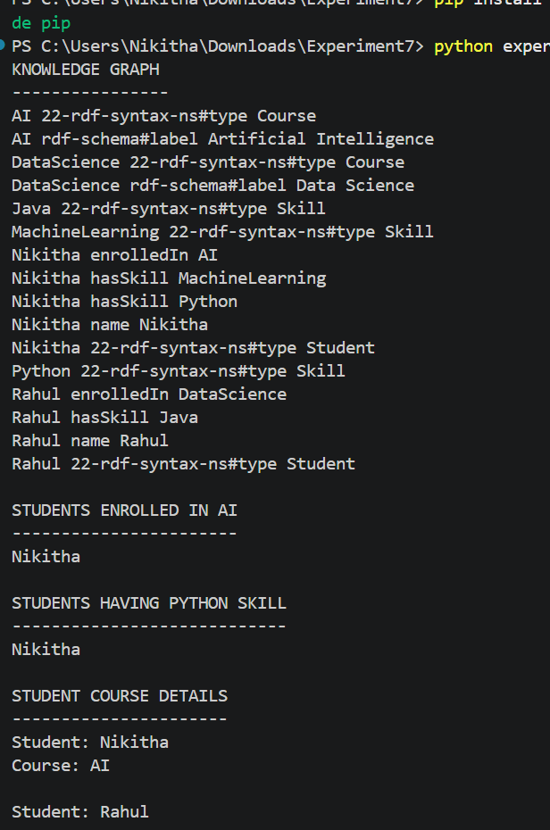

Experiment 8: Hypothesis Testing, ANOVA and Chi-Square with Evidence
Program:
# Hypothesis Testing, ANOVA and Chi-Square Test
import numpy as np
from scipy import stats
alpha = 0.05
# -----------------------------------
# PART 1: ONE-SAMPLE T-TEST
# -----------------------------------
print("ONE-SAMPLE T-TEST")
print("-----------------")
# Sample student marks
marks = np.array([52, 55, 53, 57, 54, 56, 52, 55, 54, 58])
# Hypothesized population mean
population_mean = 50
# Perform T-test
t_stat, p_value = stats.ttest_1samp(marks, population_mean)

print("Sample Marks:", marks)
print("Population Mean:", population_mean)
print("T-Statistic:", round(t_stat, 4))
print("P-Value:", round(p_value, 6))
if p_value < alpha:
print("Reject Null Hypothesis (H0)")
print("There is a significant difference in the mean.")
else:
print("Accept Null Hypothesis (H0)")
print("There is no significant difference in the mean.")
# -----------------------------------
# PART 2: ONE-WAY ANOVA
# -----------------------------------
print("\nONE-WAY ANOVA")
print("-------------")
# Marks of three groups
group1 = [78, 82, 85, 80, 79]
group2 = [88, 90, 85, 87, 91]
group3 = [72, 75, 78, 74, 76]
# Perform ANOVA test
f_stat, p_value = stats.f_oneway(
group1, group2, group3
)
print("Group 1 Marks:", group1)
print("Group 2 Marks:", group2)
print("Group 3 Marks:", group3)
print("F-Statistic:", round(f_stat, 4))
print("P-Value:", round(p_value, 6))
if p_value < alpha:
print("Reject Null Hypothesis (H0)")
print("There is a significant difference between group means.")
else:
print("Accept Null Hypothesis (H0)")
print("There is no significant difference between group means.")
# -----------------------------------
# PART 3: CHI-SQUARE TEST
# -----------------------------------
print("\nCHI-SQUARE TEST")
print("---------------")
# Observed frequency table
# Rows represent two groups
# Columns represent two course preferences
observed = np.array([
[30, 20],
[10, 40]
])
# Perform Chi-Square test
chi_stat, p_value, dof, expected = stats.chi2_contingency(
observed
)
print("Observed Frequencies:")
print(observed)
print("\nExpected Frequencies:")
print(expected)
print("\nChi-Square Statistic:", round(chi_stat, 4))
print("Degrees of Freedom:", dof)
print("P-Value:", round(p_value, 6))
if p_value < alpha:
print("Reject Null Hypothesis (H0)")
print("There is a significant association between the variables.")
else:
print("Accept Null Hypothesis (H0)")
print("There is no significant association between the variables.")
# -----------------------------------
# FINAL RESULT
# -----------------------------------
print("\nFINAL RESULT")
print("------------")
print("T-Test, ANOVA and Chi-Square tests completed successfully.")

Output:
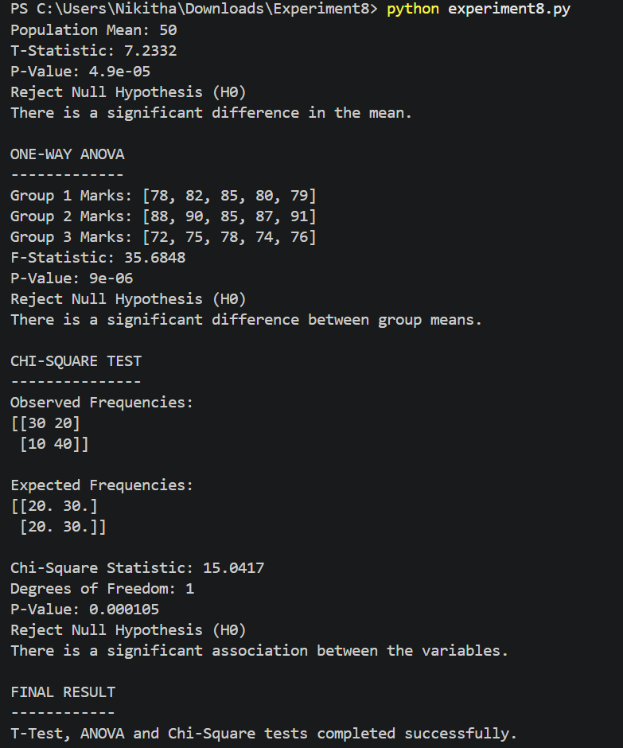

Experiment 9: Acquiring Rules from Data with Decision Trees
Program:
# EXPERIMENT 9
# Acquiring Rules Using Decision Trees
import pandas as pd
from sklearn.tree import DecisionTreeClassifier, export_text
# Step 1: Create a sample dataset

data = {
"Income": [
1, 1, 1, 1,
1, 1, 1, 1,
0, 0, 0, 0,
0, 0, 0, 0
],
"Credit_Score": [
1, 1, 0, 0,
1, 1, 0, 0,
1, 1, 0, 0,
1, 1, 0, 0
],
"Loan_Approval": [
1, 1, 0, 0,
1, 1, 0, 0,
0, 0, 0, 0,
0, 0, 0, 0
]
}
df = pd.DataFrame(data)
# Step 2: Display the dataset
print("LOAN APPROVAL DATASET")
print("---------------------")
print(df)
# Step 3: Separate input and output variables
X = df[["Income", "Credit_Score"]]
y = df["Loan_Approval"]
# Step 4: Create a Decision Tree classifier
model = DecisionTreeClassifier(
criterion="entropy",
max_depth=2,
random_state=0
)
# Step 5: Train the decision tree
model.fit(X, y)
print("\nDECISION TREE TRAINING")
print("----------------------")
print("Model trained successfully!")
# Step 6: Display acquired rules
print("\nACQUIRED DECISION RULES")
print("-----------------------")
rules = export_text(
model,
feature_names=["Income", "Credit_Score"]
)
print(rules)
# Step 7: Test the model with new data
test_data = pd.DataFrame({
"Income": [1, 0, 1, 0],
"Credit_Score": [1, 1, 0, 0]
})
predictions = model.predict(test_data)
print("\nLOAN APPROVAL PREDICTIONS")
print("-------------------------")
for i in range(len(test_data)):
income = test_data.iloc[i]["Income"]
credit = test_data.iloc[i]["Credit_Score"]
print("\nIncome:", "High" if income == 1 else "Low")
print("Credit Score:", "Good" if credit == 1 else "Poor")
if predictions[i] == 1:
print("Decision: Loan Approved")
else:
print("Decision: Loan Rejected")
# Step 8: Display model accuracy on training data
accuracy = model.score(X, y)
print("\nMODEL ACCURACY")
print("--------------")
print("Accuracy:", round(accuracy * 100, 2), "%")
# Step 9: Final result
print("\nFINAL RESULT")
print("------------")
print("Decision rules acquired successfully using Decision Tree.")
Output:
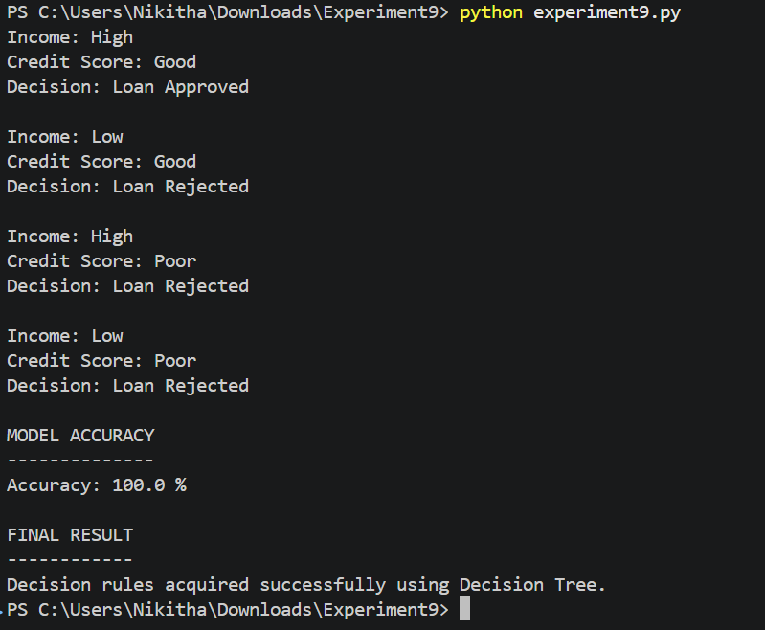

Experiment 10: Hybrid Decision-Support System (Knowledge Graph, Rules and
Machine Learning)
Program:
from sklearn.tree import DecisionTreeClassifier
# Step 1: Create sample student data
# Each row contains: [attendance, internal_marks]
X = [
[90, 85], [85, 75], [80, 65], [95, 90],
[88, 80], [78, 55], [92, 70], [82, 60],
[60, 35], [65, 45], [70, 30], [55, 50],
[72, 38], [68, 25], [50, 40], [74, 55],
[90, 30], [60, 80], [85, 35], [70, 75]
]
# Step 2: Define the performance categories
# 1 = Good, 0 = At Risk
y = [
1, 1, 1, 1, 1, 1, 1, 1,
0, 0, 0, 0, 0, 0, 0, 0,
0, 0, 0, 0
]
# Step 3: Train the machine-learning model
model = DecisionTreeClassifier(max_depth=2, random_state=0)
model.fit(X, y)
print("HYBRID DECISION-SUPPORT SYSTEM")
print("--------------------------------")
# Step 4: Get new student details
attendance = float(input("Enter attendance percentage: "))
marks = float(input("Enter internal marks: "))
# Step 5: Predict using machine learning
prediction = model.predict([[attendance, marks]])[0]
if prediction == 1:
result = "Good"
else:
result = "At Risk"
print("\nMachine Learning Prediction:", result)
# Step 6: Apply rule-based reasoning
print("\nRule-Based Recommendation:")
if attendance < 75:
print("Rule Applied: Attendance is below 75%.")
print("Recommendation: Improve attendance.")
elif marks < 40:
print("Rule Applied: Internal marks are below 40.")
print("Recommendation: Attend remedial classes.")
elif prediction == 0:
print("Rule Applied: Machine learning identified academic risk.")
print("Recommendation: Faculty guidance is required.")
else:
print("Rule Applied: Attendance and marks are satisfactory.")
print("Recommendation: Continue the good performance.")
# Step 7: Display final decision
print("\nFINAL DECISION")
print("----------------")
print("Student Performance:", result)
print("Decision Support: Recommendation generated successfully.")
Output:


